**Project #2 for MSDS 6372-4023**

**Recovery of Patients from Stroke Repeated Measures Study**

**July 13, 2017**

**Jethin Abraham**

**Asha Saxena**

**Leticia Valadez**

**Course: MSDS 6372-4023 (Mon, 8:30 to 10:00 PM)**

## **Problem Description**

Every year approximately 795,000 strokes occur in the United States, resulting often in serious long-term disability.1 People who have suffered from stroke participate in occupational therapy to help recover occupational functionality, but therapy is expensive and maximal recovery often depends on repetitive, tedious exercises to be done by patients both in therapy sessions and on their own. Often patients do not have the resources or motivation to complete the treatment required to give them the best results. Finding methods to decrease the longevity of disability would prove beneficial to these individuals. This paper presents a study comparing occupational therapy programs designed to speed up the recovery process.2 Barthel Index is one of the measures that is used in this study to determine the level of functional disability and to determine if one therapy program has more potential for improving functional movement. Using longitudinal repeated measures analysis, we are trying to determine if there is a significant difference in the result after the patient is exposed to the two different therapy programs.

## **Dataset Background**

The dataset analyzed in this paper comes from paper “Occupational Therapy and the Treatment of Stroke”2; however, the data is more accessible through the following website <http://www.statsci.org/data/oz/stroke.html>. For this study, three occupations therapy programs are evaluated for potentially improving the effects from a stroke. Each therapy program or treatment group consists of eight stroke patients and lasted for eight weeks. The three treatment groups are as follow: Group E received an experimental program developed by the investigator from a model of intervention for stroke rehabilitation. Group F received a pre-existing program. Group G received a non-treatment program. A Barthel Index measurement as well as other measure were taken during weekly intervals for the duration of the eight-week program. The Barthel Index measures how well one functions independently and their mobility level during daily activities such as feeding, bathing, grooming, dressing, bowel control, bladder control, toileting, chair transfer, ambulation and stair climbing. Group E and F patients were treated in the Occupational Therapy Department of a large Brisbane repatriation hospital while group G patients were in the wards of a large State Hospital in Brisbane. The dataset includes two types of measurements, Goteburg Evaluation of Hemiplegia and the Barthel Index. The Goteburg provides separate scores for three motor function variables (upper limbs, hand and wrist, lower limbs) and for balance while the Barthel Index gave a single overall score. Higher scores indicate better functional ability. For this study only the Barthel Index is only considered.

## **Dataset Description**

The original dataset as shown in Table 1.1. consists of both Goteburg Evaluation of Hemiplegia and Barthel Index measurements and holds 46 variables with 24 observations. The dataset consists of both Goteburg Evaluation of Hemiplegia and Barthel Index measures. Both types of measurements share the categorical variables- group, subject, sex, side and continuous variables age and lapse. The group variable has values E, representing the group receiving new experimental treatment, F, representing the group receiving pre-existing treatment and G, representing the group receiving no treatment. Subject has values I-VII, 1-8, and A-H, respectively, for Group E, Group F and Group G. Sex is either Male (M) or female (F). Side represents the side of brain that was affected, either left (L) or right (R). Age represents the subject in years. Lapse represents the time lapse from the stroke. For the Evaluation of Hemiplegia measures, there 16 continuous variables which are UE1-UE8 that measure the upper extremities with a score out of 36, HW1-HW8 that measures the hand-wrist with a score out of 24, LE1-LE8 that measure the lower extremities with a score out of 30 and Bal1-Bal8 that measures balance with a score out of 24. Each of these different measures have a variable for each of the 8 weeks of the treatment; for example, the upper extremities UE1 represents the score for week 1, UE2 represents the score for week 2 and continues until week 8 (UE8). This variable set up is the same for hand-wrist, lower extremities, and balance scores as well as for the Barthel Index score, where there are continuous variables Bart1-Bart8 with scores out of 100. Higher scores indicate better functional ability. For this study only the Barthel Index is only considered.

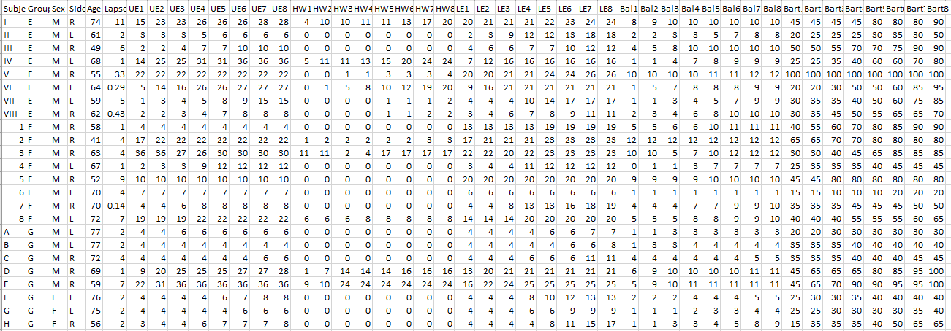

## **Table 1.1. Date Set – Wide**

### **Transposing the data**

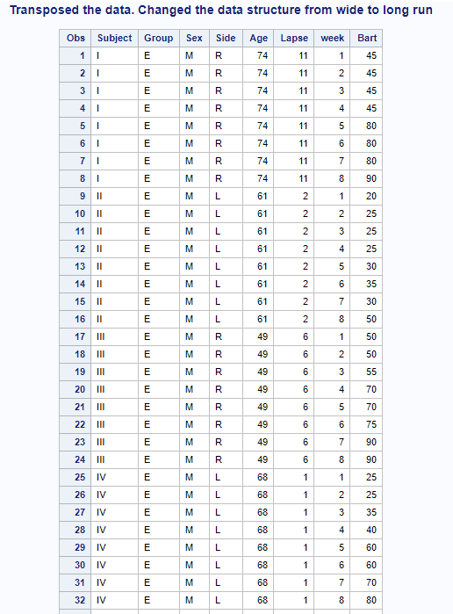The original data set format is wide which is at week level for the Bart Index. However, for creating the model and to use Proc Mixed, we had to transpose the data to long as shown in Table 1.2. This would help us to build the model using Proc mix and use the repeating factor.

**Table 1.2. Transposed Data Set- Long**

For Subject 5 as shown in Table 1.3., Bart Score is 100 for all weeks and lapse period is 33 weeks. The score indicates that the subject has strong index, this seems to be an outlier and hence we would remove this subject from our model to get a perfect fit.

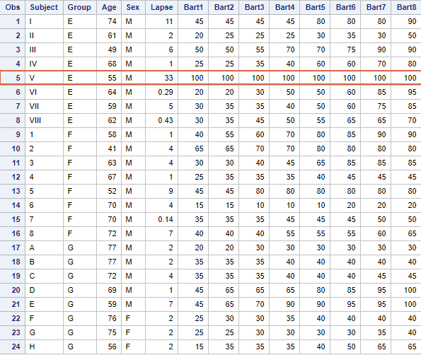

**Table 1.3. Outlier in the Data Set**

## **Limitations:**

In this analysis, the data set is small, less than 30. The treatment was carried out at different hospital facilities and different occupational therapists. The amount of time that lapsed between stroke and the treatment will have an influence on the recovery.

## **Data Analysis**

For this analysis, our goal is to get an understanding on the effectiveness of the group and the progress of the treatment across 8 weeks. To achieve this, we would be considering only the Bart Index while compared to the Goteburg index because the Bart Index is an average score of all the 3-motor function while compared to Goteburg where individual scores are provided for different motor variables.

We start with the Proc Mean for the continuous variables. From Table 1.4, the mean average of the age variable is 64 and the minimum age is 41 while maximum age is 77. This is alarming that someone of age 41 could have a stroke! The lapse is the time-period when the subjects enter the therapy program after they encounter the stroke. Per the Table 1.4, we see that the minimum days for the program to start is from 0 to maximum of 33 days. This means that we have subjects who are a part of the program for 33 weeks after suffering from stroke while the median is 2 weeks. As shown in Table 1.3, this is considered an outlier for our study and has been removed from the data set.

Considering the Bart score from Week 1- 8, as seen in Figure 1.1, there is a gradual increase in the Bart Score across all the groups. From the initial analysis, the subjects do see an improvement in the Bart Score over the weeks. This can be considered as we create the model.

|  |
| --- |
|  |
| **Table 1.4. Means Procedure- Bart Score descriptive stats for 8 weeks** |
|  |
| **Figure 1.1. Scatter Plot for Bart Index over weeks** |

Box Plot Comparison

The comparison of the raw data for the three groups, Group E, F and G for the Bart Index is as follows:

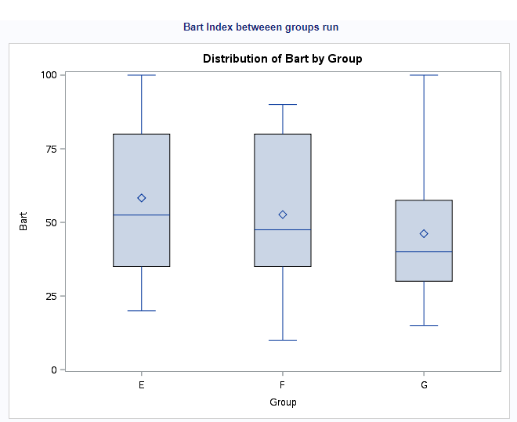

**Figure 1.2. Box Plot for Group vs Bart Index**

The raw data shows a very slight difference between Group E, the new treatment, the therapy program compared to the old treatment, the therapy program, Group F. The median between the groups vary especially for Group E & F whereas Group G presents the placebo effect, no treatment for this group.

## **Testing the MANOVA Assumptions for Normality**

|  |
| --- |
|  |
| Residual plots analysis for checking assumptions   * Studentized Residual Plot: The residual plot resembles somewhat of a random scatter of points Since there are repeated measures we can expect overlapping of values around that range * QQPlot of Residuals: The QQ Plot of residuals displayed above provides no evidence that the residuals are not normally distributed. * Histogram of Residuals: The histogram of residuals displayed above provides evidence that the residuals are normally distributed. There seems to be a slight skewness towards the right but we can consider the data to be normally distributed because of the observation to be less than 30. * Cooks D: We can see high influence points at around 30 and 150. Care would be taken while fitting the model. |

We study the three groups further as we conduct our MANOVA test and build our comparison models. Since the assumption of normality is met we can move forward to test equality of two or more independent covariance matrices under the assumption of normality.

|  |
| --- |
|  |
| Test for Equality of Covariance Matrices |

**Table 1.5. Chi-Square Statistics**

The Chi-Square test statistic (Table 1.5.) is not significant (p=0.5853), therefore, we fail to reject the null hypothesis of equal covariance matrices. This provides strong evidence that the covariance matrices are the same.

## **Analysis Procedure**

In this analysis we have two options, either to choose PROC GLM or PROC MIXED. We use PROC MIXED for our analysis as it is a natural extension and has several programming tools of GLM like contrasts and ANOVA tables. We don’t need to transform the data and the estimation technique gets standard errors correct in split plot designs, parameters that are strictly positive and can sometimes be estimated as negative in GLM. It can fit sphericity, multivariate approach of GLM, as well as a wide number of other structures, use AIC or BIC to model select as shown in Table 1.6. For our MANOVA model in SAS, the F test comes back significant.

### **Over all Model Fit**

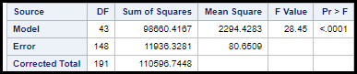

**Table 1.6. MANOVA Statistics**

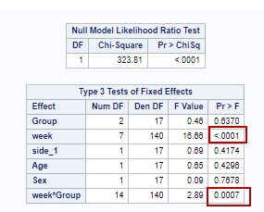

**Table 1.7. Type 3 Test**

Looking at the Figure 1.7., we can see that the group , sex ,side and age are not statistically significant because of a high p-value greater than 0.05, hence we fail to reject the null hypothesis. However, the week,Group and Week interaction are statistically significant and influence the model (p=0.0006). We further investigate which group and week combination has a difference. We use the slice function via PROC MIXED at the week and group level as shown in Table 1.8., to show that the week and group interactions are significant at the group level (E, F & G) and significant only for Week 8. Further looking deeper into this and a different level gives us more insight

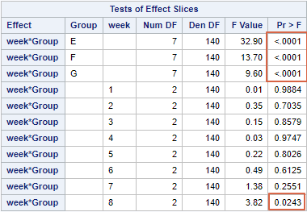

**Table 1.8. Interaction Sliced by Week and Group**

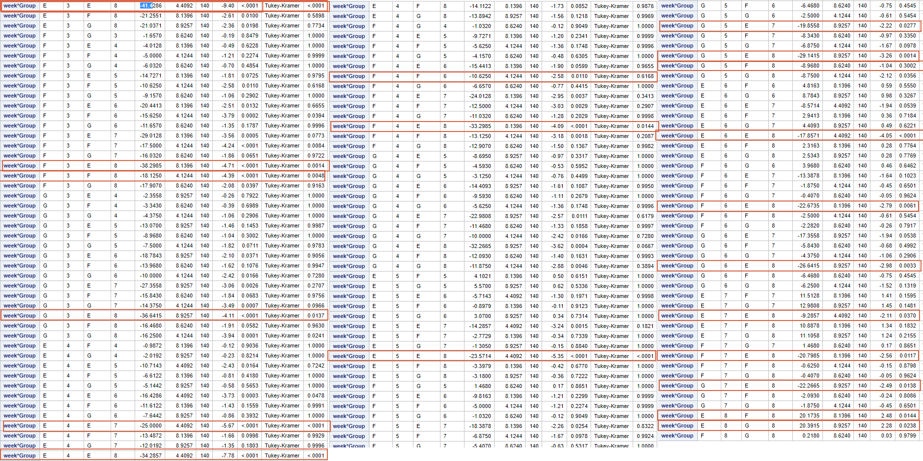

**Table 1.9. Interaction Sliced by Week and Group**

Table 1.9 shows the week group interaction across an individual group at a particular week suggesting further diving is necessary.

**Analysis within Group E, F & G for Week and Group Interaction for ALL Weeks**

The analysis of within group E, F & G for week and group interactions, as shown in Table 3.0 found in Appendix A, displays that there is a significant difference in the Bart Index from Week 2 onwards and most of the difference can be seen between the Week 6 and Week 8. Group E seems to show a slightly better significance than F and G as well. Also. in all the groups, there seems to be no effect at Week 6.

**Analysis within Group E, F & G for Week 8**

Once reviewing the results found in Table 1.8, we proceeded to review week 8 for further analysis.

Table 2.0 shows that Group E and Group F have a significance at week 8. Also, Group E and Group G show a significance at Week 8.

|  |
| --- |
|  |
| Week 8 only |

**Table 2.0 Difference bet Groups for Week 8**

## **Conclusion**

The analysis concludes there is no significant difference between the three therapy programs when comparing the Barthel Index measures; however, the week and group interactions are significant using the Tukey contrast method. After Repeated Measures of MANOVA, a significant difference between Week 8 of measurements compared to the earlier weeks is revealed. Strong progress can be seen at Week 8, hence, we can say that period of the treatment does help in improving the recovery of the stroke patients. For Week 8, specifically on the final week of the treatment, we could see strong statistical evidence of differences between group E with F and G. Since Group G was more of a non-treatment group having a placebo effect, we are 95% confident that group E has a slightly better Bart scores when compared to the other groups with respect to the week as time-period and keeping all the other variables constant. More analysis needs to be done with more subjects and the rest of the data set that includes Goteburg Evaluation of Hemiplegia measures. Code has been added in Appendix C to evaluate the Goteburg Evaluation using the same analysis procedure for Bart Index measures.

## **References**

1. <http://www.strokecenter.org/patients/about-stroke/stroke-statistics/>
2. Cropper, C. (1977). Occupational Therapy and the Treatment of Stroke. Honours Thesis T18, Department of Occupational Therapy, University of Queensland, January 1977.

## **Appendix - A**

**Tables 3.0. Analysis within Group E, F & G for Week and Group Interaction F & G for Week and Group Interaction**

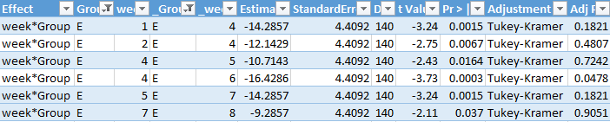

**Group E with Other groups**

|  |  |  |  |  |  |  |  |  |  |  |  |
| --- | --- | --- | --- | --- | --- | --- | --- | --- | --- | --- | --- |
| **Effect** | **Group** | **week** | **_Group** | **_week** | **Estimate** | **StandardError** | **DF** | **t Value** | **Pr > |t|** | **Adjustment** | **Adj P** |
| week*Group | E | 1 | F | 5 | -20.8979 | 8.1396 | 140 | -2.57 | 0.0113 | Tukey-Kramer | 0.6234 |
| week*Group | E | 1 | G | 5 | -19.43 | 8.9257 | 140 | -2.18 | 0.0312 | Tukey-Kramer | 0.8744 |
| week*Group | E | 1 | F | 6 | -25.8979 | 8.1396 | 140 | -3.18 | 0.0018 | Tukey-Kramer | 0.209 |
| week*Group | E | 1 | G | 6 | -21.93 | 8.9257 | 140 | -2.46 | 0.0152 | Tukey-Kramer | 0.7052 |
| week*Group | E | 1 | F | 7 | -27.7729 | 8.1396 | 140 | -3.41 | 0.0008 | Tukey-Kramer | 0.1178 |
| week*Group | E | 1 | G | 7 | -26.305 | 8.9257 | 140 | -2.95 | 0.0038 | Tukey-Kramer | 0.3433 |
| week*Group | E | 1 | F | 8 | -28.3979 | 8.1396 | 140 | -3.49 | 0.0006 | Tukey-Kramer | 0.0956 |
| week*Group | E | 1 | G | 8 | -28.18 | 8.9257 | 140 | -3.16 | 0.002 | Tukey-Kramer | 0.221 |
| week*Group | E | 2 | F | 5 | -18.7551 | 8.1396 | 140 | -2.3 | 0.0227 | Tukey-Kramer | 0.8062 |
| week*Group | E | 2 | F | 6 | -23.7551 | 8.1396 | 140 | -2.92 | 0.0041 | Tukey-Kramer | 0.3624 |
| week*Group | E | 2 | G | 6 | -19.7871 | 8.9257 | 140 | -2.22 | 0.0282 | Tukey-Kramer | 0.8548 |
| week*Group | E | 2 | F | 7 | -25.6301 | 8.1396 | 140 | -3.15 | 0.002 | Tukey-Kramer | 0.2253 |
| week*Group | E | 2 | G | 7 | -24.1621 | 8.9257 | 140 | -2.71 | 0.0076 | Tukey-Kramer | 0.5163 |
| week*Group | E | 2 | F | 8 | -26.2551 | 8.1396 | 140 | -3.23 | 0.0016 | Tukey-Kramer | 0.1885 |
| week*Group | E | 2 | G | 8 | -26.0371 | 8.9257 | 140 | -2.92 | 0.0041 | Tukey-Kramer | 0.3633 |
| week*Group | E | 3 | F | 6 | -18.7551 | 8.1396 | 140 | -2.3 | 0.0227 | Tukey-Kramer | 0.8062 |
| week*Group | E | 3 | F | 7 | -20.6301 | 8.1396 | 140 | -2.53 | 0.0124 | Tukey-Kramer | 0.6482 |
| week*Group | E | 3 | G | 7 | -19.1621 | 8.9257 | 140 | -2.15 | 0.0335 | Tukey-Kramer | 0.8881 |
| week*Group | E | 3 | F | 8 | -21.2551 | 8.1396 | 140 | -2.61 | 0.01 | Tukey-Kramer | 0.5898 |
| week*Group | E | 3 | G | 8 | -21.0371 | 8.9257 | 140 | -2.36 | 0.0198 | Tukey-Kramer | 0.7734 |
| week*Group | E | 8 | F | 8 | 20.1735 | 8.1396 | 140 | 2.48 | 0.0144 | Tukey-Kramer | 0.6897 |
| week*Group | E | 8 | G | 8 | 20.3915 | 8.9257 | 140 | 2.28 | 0.0238 | Tukey-Kramer | 0.8177 |

**Group E seems to have maximum interaction across 8 weeks within the group as well with other groups.**

**Group F**

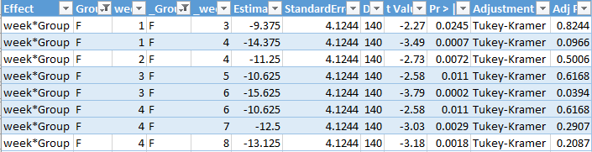

**Group F with other Groups**

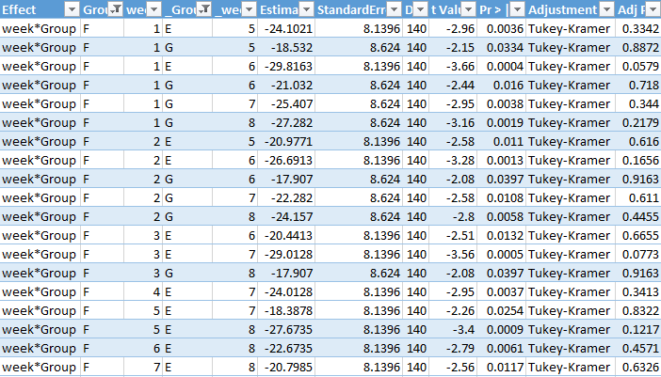

**Group G**

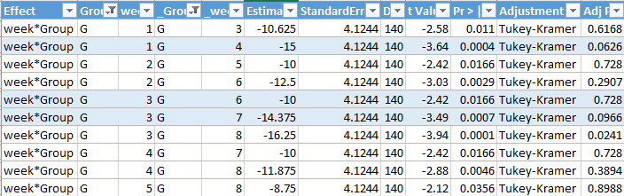

**Group G with other groups**

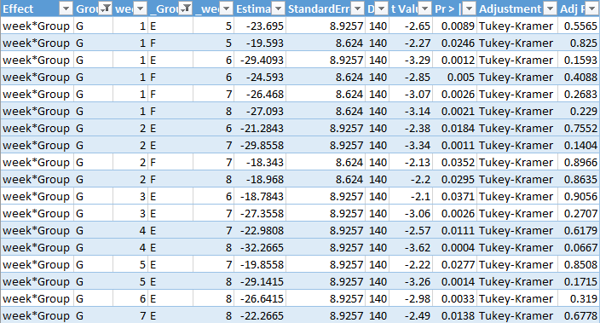

**Only Week 8**



## **Appendix - B**

**Barthel Index SAS Code**

FILENAME REFFILE '/pathname/PROJECT2/Stroke_Raw.csv';

PROC IMPORT DATAFILE=REFFILE  
 DBMS=CSV  
 OUT=WORK.stroke_raw;  
 GETNAMES=YES;  
RUN;  
PROC CONTENTS DATA=WORK.stroke_raw; RUN;  
  
  
*******************Clean Data******************************************;  
data stroke_clean;  
set stroke_raw;  
IF GROUP IN ('E') THEN GROUP_NUM=1;  
IF GROUP IN ('F') THEN GROUP_NUM=2;  
IF GROUP IN ('G') THEN GROUP_NUM=3;  
run;  
  
************************Transpose Data**********************************;  
************************Bart_Transpose**********************************;  
************************************************************************;  
  
data stroke_Bart_T;  
set stroke_raw;  
 week = 1 ;  
 Bart = Bart1 ;  
 OUTPUT ;  
 week = 2 ;  
 Bart = Bart2 ;  
 OUTPUT ;  
 week = 3 ;  
 Bart = Bart3 ;  
 OUTPUT ;  
 week = 4 ;  
 Bart = Bart4 ;  
 OUTPUT ;  
 week = 5 ;  
 Bart = Bart5 ;  
 OUTPUT ;  
 week = 6 ;  
 Bart = Bart6 ;  
 OUTPUT ;  
 week = 7 ;  
 Bart = Bart7 ;  
 OUTPUT ;  
 week = 8 ;  
 Bart = Bart8 ;  
 OUTPUT ;  
 DROP Bart1-Bart8 ; run;  
  
   
*Removing the outlier;  
data stroke_Bart_V1;  
set stroke_Bart_T;  
if side='R' then side_1=1; *give a numerical value to side;  
if side='L' then side_1=0;  
where Bart <99;  
run;  
  
*Determine if there is significant between groups;

proc mixed data=stroke_Bart_V1 plots=all;

class group week subject;

model Bart=group week group*week;

lsmeans group /pdiff=all adjust=tukey;

repeated group/ type=CS subject=subject;

run;  
  
*Final Model;  
proc mixed data=stroke_Bart_V1 plots=all;  
class week group side_1 sex subject;  
model bart=group week side_1 sex group*week;  
lsmeans group*week / slice=group;  
lsmeans group*week / slice=week;  
repeated week / type=CS subject=subject;  
run;  
  
  
*Test to see if there is significant difference between groups for week 8;  
data week8;  
set stroke_Bart_V1;  
where week=8;  
  
   
proc mixed data=week8 plots=all;  
class group side sex subject;  
model bart=group side sex age;  
lsmeans group/pdiff=all adjust=tukey;  
*lsmeans side sex / slice=group;  
estimate 'Is there a difference in groups?' group 1 1 -2/ divisor=2;  
run;  
  
  
  
* The Exploratory Data Analysis;  
**summary statistics;  
Proc GPlot Data=stroke_Bart_T;  
 Plot bart*week=Group / VAxis=Axis1 Legend=Legend1;  
 Axis1 Label=(A=90);  
 Legend1 Position=(Inside Top Left) Across=1 Frame;  
 Symbol1 C=Red V=Dot I=None;  
 Symbol2 C=Black V=Circle I=None;  
Run; Quit;  
   
  
Proc means data =stroke_raw N MEAN STD MIN Q1 median Q3 MAX SKEWNESS;  
var Age lapse Bart1-Bart8;run;*Box plot analyis;proc sort data=stroke_Bal_T;  
by group;proc print data=Stroke_bart_t; proc boxplot data=stroke_Bart_T;   
plot Bart*Group; title 'Bart Index betweeen groups'; run;

## **Appendix - C**

**Goteburg Evaluation of Hemiplegia SAS code and Output**

**\*\*NOTE-this is sample code for only the UE data but other measure gave similar outcomes and conclusions for treatment programs. Towards the end of the code you can replace “UE” with HW, LE, Bal or Bart after the word model to analyze that measurement.**

FILENAME REFFILE '/pathname/Stroke_Raw.csv';

PROC IMPORT DATAFILE=REFFILE

DBMS=CSV

OUT=WORK.stroke_raw;

GETNAMES=YES;

RUN;

PROC CONTENTS DATA=WORK.stroke_raw; RUN;

proc print data=stroke_raw;

run;

data stroke_clean;

set stroke_raw;

IF GROUP IN ('E') THEN GROUP_NUM=1;

IF GROUP IN ('F') THEN GROUP_NUM=2;

IF GROUP IN ('G') THEN GROUP_NUM=3;

run;

proc print data=stroke_clean;

run;quit;

******************************

****Transpose Data***

******************************;

data stroke_UE;

set stroke_clean;

keep subject age sex side group lapse UE1 UE2 UE3 UE4 UE5 UE6 UE7 UE8

;

data stroke_LE;

set stroke_clean;

keep subject age sex side group lapse LE1 LE2 LE3 LE4 LE5 LE6 LE7 LE8

;

data stroke_HW;

set stroke_clean;

keep subject age sex side group lapse HW1 HW2 HW3 HW4 HW5 HW6 HW7 HW8

;

data stroke_Bal;

set stroke_clean;

keep subject age sex side group lapse Bal1 Bal2 Bal3 Bal4 Bal5 Bal6 Bal7 Bal8;

data stroke_Bart;

set stroke_clean;

keep subject age sex side group lapse Bart1 Bart2 Bart3 Bart4 Bart5 Bart6 Bart7 Bart8

;

*********************UE_Transpose******************************

***************************************************************;

data stroke_UE_T;

set stroke_UE;

week = 1 ;

UE = UE1 ;

OUTPUT ;

week = 2 ;

UE = UE2 ;

OUTPUT ;

week = 3 ;

UE = UE3 ;

OUTPUT ;

week = 4 ;

UE = UE4 ;

OUTPUT ;

week = 5 ;

UE = UE5 ;

OUTPUT ;

week = 6 ;

UE = UE6 ;

OUTPUT ;

week = 7 ;

UE = UE7 ;

OUTPUT ;

week = 8 ;

UE = UE8 ;

OUTPUT ;

DROP UE1-UE8 ;

run;

************************HW_Transpose************************************

************************************************************************;

data stroke_HW_T;

set stroke_HW;

week = 1 ;

HW = HW1 ;

OUTPUT ;

week = 2 ;

HW = HW2 ;

OUTPUT ;

week = 3 ;

HW = HW3 ;

OUTPUT ;

week = 4 ;

HW = HW4 ;

OUTPUT ;

week = 5 ;

HW = HW5 ;

OUTPUT ;

week = 6 ;

HW = HW6 ;

OUTPUT ;

week = 7 ;

HW = HW7 ;

OUTPUT ;

week = 8 ;

HW = HW8 ;

OUTPUT ;

DROP HW1-HW8 ;

run;

************************LE_Transpose************************************

************************************************************************;

data stroke_LE_T;

set stroke_LE;

week = 1 ;

LE = LE1 ;

OUTPUT ;

week = 2 ;

LE = LE2 ;

OUTPUT ;

week = 3 ;

LE = LE3 ;

OUTPUT ;

week = 4 ;

LE = LE4 ;

OUTPUT ;

week = 5 ;

LE = LE5 ;

OUTPUT ;

week = 6 ;

LE = LE6 ;

OUTPUT ;

week = 7 ;

LE = LE7 ;

OUTPUT ;

week = 8 ;

LE = LE8 ;

OUTPUT ;

DROP LE1-LE8 ;

run;

************************Bal_Transpose************************************

************************************************************************;

data stroke_Bal_T;

set stroke_Bal;

week = 1 ;

Bal = Bal1 ;

OUTPUT ;

week = 2 ;

Bal = Bal2 ;

OUTPUT ;

week = 3 ;

Bal = Bal3 ;

OUTPUT ;

week = 4 ;

Bal = Bal4 ;

OUTPUT ;

week = 5 ;

Bal = Bal5 ;

OUTPUT ;

week = 6 ;

Bal = Bal6 ;

OUTPUT ;

week = 7 ;

Bal = Bal7 ;

OUTPUT ;

week = 8 ;

Bal = Bal8 ;

OUTPUT ;

DROP Bal1-Bal8 ;

run;

************************Bart_Transpose************************************

************************************************************************;

data stroke_Bart_T;

set stroke_Bart;

week = 1 ;

Bart = Bart1 ;

OUTPUT ;

week = 2 ;

Bart = Bart2 ;

OUTPUT ;

week = 3 ;

Bart = Bart3 ;

OUTPUT ;

week = 4 ;

Bart = Bart4 ;

OUTPUT ;

week = 5 ;

Bart = Bart5 ;

OUTPUT ;

week = 6 ;

Bart = Bart6 ;

OUTPUT ;

week = 7 ;

Bart = Bart7 ;

OUTPUT ;

week = 8 ;

Bart = Bart8 ;

OUTPUT ;

DROP Bart1-Bart8 ;

run;

****************************************************************

************************Merging the Data************************

Remove outlier;

****************************************************************;

data stroke_merge;

set stroke_UE_T;

set stroke_HW_T;

set stroke_LE_T;

set stroke_Bal_T;

set stroke_Bart_T;

where lapse<30; *Remove outlier;

if side='R' then side_1=1; *assign side a numerical value;

if side='L' then side_1=0;

run;

***************Analyzed Model;

***********

for model you can substitute HW, LE, Bal or Bart after the word model to analyze that measurement.;

proc mixed data=stroke_merge plots=all;

class week group side_1 sex subject;

model UE=group week side_1 sex group*week;

*lsmeans week /pdiff=all adjust=tukey;

lsmeans group*week / slice=group;

lsmeans group*week / slice=week;

repeated week / type=CS subject=subject;

run;

**Are there difference in treatment groups?;

proc mixed data=stroke_merge plots=all;

class group week subject;

model UE=group week group*week;

lsmeans group /pdiff=all adjust=tukey;

repeated group/ type=CS subject=subject;

run;

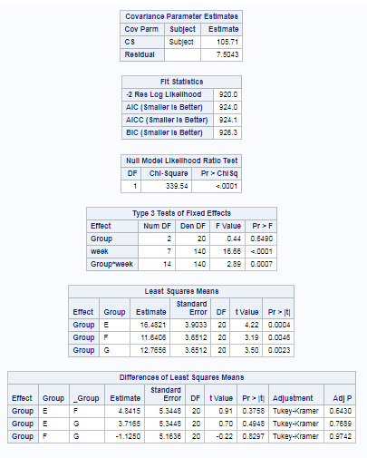No Difference in groups using UE scores.